Project Analysis

KALAKAL:

A B2B Ecommerce Website Platform

**BSCS-3A**

Antiquando, Aaron Mark

Dela Cruz, Bia

Muncada, John Paul

Saguion, Maria Shaina

**BSCS-3B**

Aquino, Kyle Shaun

Evangelista, Elisha

Pepito, Nicail

Submitted to:

Prof. May Garcia

# Problem Diagnosis:

* Commerce for small business inside and outside the metro has always been manual
* Buyers need to physically go to the vendors location to purchase the goods
* The goods are then brought to tracking services for the transportation of goods to the buyer’s location

# Proposed Treatment

* With the rising use of the internet as the main tool of communication and connectivity, E-commerce have paved way in creating a new digital economy to almost any industry that relates to goods. Kalakal will be the solution in the problem of manual processes of goods for small businesses. It aims to manage the inventory, sales, delivery and customer support of vendors while also being the portal of transaction of goods for their customers.

# Plan of Work:

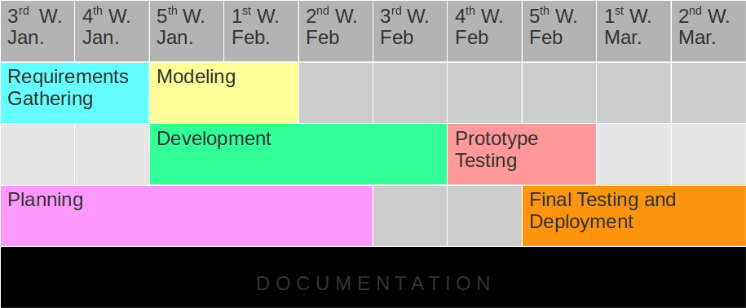

1. **Communication**

* The system will be brainstormed and deliberated by the development team
* Updates and Modifications will be done after the end of the development cycle
* Prototype will be tested by chosen users and shall deliver necessary reports on the improvement of the system

1. **Planning**

* The planning team composed of System Analyst, Frontend and Backend Developers  will be collecting the data necessary to the development of the application and compile it in a more logical manner
* The documentation will take notes of the proposed plan to be submitted to the modelling team

1. **Modelling**

* The Backend and Frontend developers will collect the report the planning team made to implement the fundamental modules of the system

1. **Development**

* The Programmers will connect the modules made by the frontend and Backend Developers to generate a web app prototype for beta testing

1. **Deployment**

* When all requirements is satisfied. The project is now complete and is ready for deployment

# Software Requirements:

## Interview:

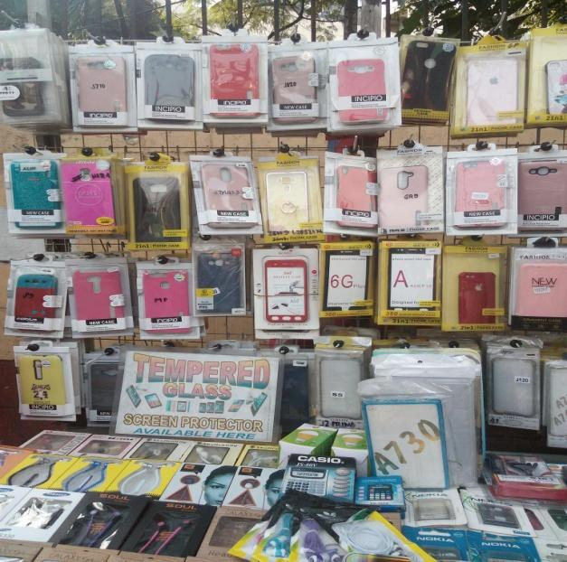 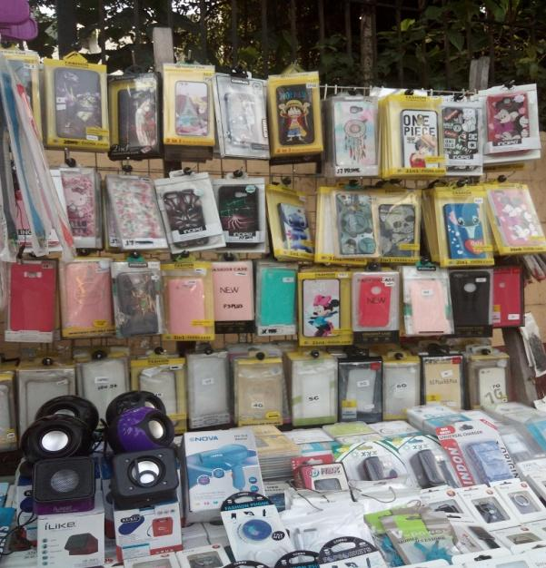

** **

# User Stories:

* As a user, I want the system to be user-friendly so that it will easy to navigate.
* As a consumer, I want a schedule date to pay so that I know when to pay and prepare for it.
* As a seller, I want to lessen my time and effort in buying so that I have more time to sell.
* As a user, I want a tracker so that I know when will my order be delivered and location of my ordered items.
* As a user, I want a private message so that I can ask other question.
* As a user, I want details of item so that I have the idea not only I see in the picture.
* As a user, I want reviews of item so that I could decide by the help of others about the item.
* As a user, I want to write reviews so that I can help others to decide.
* As a consumer, I want to have discounts and promos so that I would enjoy buying more.
* As a seller, I want to have advertisement of my items so that it will be seen of people.

# 

# Functional Requirements:

|  |  |  |  |
| --- | --- | --- | --- |
| Purpose | Process | Operation | Output |
| To let the customer to decide about the product’s quality. | Adding to cart | 1. Select Items 2. Click on Add to cart | 1. Selected Items should be displayed on checkout page 2. Total amount should be calculated |
| To see the sub total of the products. | Adding to cart | 1. Select Items 2. Select quantity 3. Click on Add to cart | 1. Selected items should be displayed with its quantity 2. Total amount should be calculated accordingly |
| To be able to see the product selected even if you switch to the website other pages. | Keeping the site idle for sometime after adding products to cart | 1. Select Items 2. Click on Add to Cart 3. leave the site for sometime | After coming back, items should be still visible in the cart |
| To remove the things you don’t want to purchase and the sub total will decrease. | Remove items from the cart | 1. Select 2-3 Items 2. Click on Add to Cart 3. On cart page remove one item | After removing one item payment should update |
| To double check the customer if you really want to cancel it or not. | Check Cancel Button | 1. Select 2-3 Items 2. Click on Add to Cart 3. Click on cancel button | 1. It should not redirect to payment 2. Item should not remove from cart |
| To validate the inputs of the user. | Check the error message when enter invalid input for mandatory fields | 1. Select the card type 2. Enter invalid card number [Check for CVV, Expiration date] 3. Click on submit button | It should show error message for invalid details |
| To let the customer know that their transaction is successfully done. | Check the redirection after successful payment | 1. Select the card type 2. Enter valid details 3. Click on submit button | 1. Payment should done successfully. 2. It should redirect to site home page with proper details. 3. It should show order no on thank you page. |

# Navigation Structure

1. Homepage
2. Dashboard
3. Orders
4. Invoice
5. Customer
6. Billing
7. Reports
8. Products
9. Store
10. Account Settings

# User and Administrator Sections

1. Customer Section
2. Global Store
3. Vendor Administrator Section
4. Vendor Store Section
5. Manufacturer Administrator Section
6. Manufacturer Store Section

# 

# Requirements Engineering

INCEPTION

The target stakeholders of KALAKAL: A B2B Ecommerce Website are the wholesalers, vendors and manufacturers. As we all know, there are ecommerce system that sell at retail but sometimes we want to buy in bulk. So a solution was proposed, it is an ecommerce website that sell in a large quantities of item with a track of inventory, sales and costumers, and it will be delivered hassle-free to the consumer.

ELICITATION

The vendors want to manage a business that would definitely satisfy their customers, even to the proposed website, we convince wholesalers to use the website as their POS and inventory system. It is efficient to use the proposed website for they can easily organize their POS and inventory. Additionally, the technology is booming and it is now easier to spread things through the internet. It may be useful for the consumer for just a click you will have the items you want to buy in bulk and follow the necessary requirements to be delivered.

SPECIFICATION

The KALAKAL website would have the following features: support all process from inventory to sales for both vendors and customers, hence, it will lessen the time and effort of transactions, an ecommerce CMS platform for wholesalers and consumers for buying and selling of goods, and tracking system for the delivery of goods. Wholesalers, vendors and manufacturers are also the users of the KALAKAL website, they manage specific roles in the website to have transaction in the consumer. The website shows all the goods and products in picture and details they have.

# 

# Tools and Requirements:

* **Project - Management:** Github
* **Repository Link:** https://github.com/kyleaquino/WebDev_Project.git
* **Client-Side Scripts:** HTML, CSS, Javascript
* **Server-Side Scripts:** PHP, MySQL
* **Frameworks (Client-Side/Server-Side):** Codeigniter, Bootstrap

# 

# Mockups





# Software Design:

**Use-Case Diagram:**

